**Term-3**

**1.Create class Student with attributes(id,name and marks), create a spring application to create its object(using DI) and invoke methods. In this application also inject properties through autowiring process(by Name).**

**Marks.java**

**package** myterm;

**public** **class** Marks {

**private** **int** math;

**private** **int** phy;

**private** **int** che;

**public** **int** getMath() {

**return** math;

}

**public** **void** setMath(**int** math) {

**this**.math = math;

}

**public** **int** getPhy() {

**return** phy;

}

**public** **void** setPhy(**int** phy) {

**this**.phy = phy;

}

**public** **int** getChe() {

**return** che;

}

**public** **void** setChe(**int** che) {

**this**.che = che;

}

@Override

**public** String toString() {

**return** "Marks [math=" + math + ", phy=" + phy + ", che=" + che + "]";

}

}

**Student.java**

**package** myterm;

**public** **class** Student {

**private** **int** Id;

**private** String name;

**private** Marks marks;

**public** **int** getId() {

**return** Id;

}

**public** **void** setId(**int** id) {

Id = id;

}

**public** String getName() {

**return** name;

}

**public** **void** setName(String name) {

**this**.name = name;

}

**public** Marks getMarks() {

**return** marks;

}

**public** **void** setMarks(Marks marks) {

**this**.marks = marks;

}

**void** displayInfo(){

System.***out***.println(Id+" "+name);

System.***out***.println(marks);

}

}

**Main.java**

**package** myterm;

**import** org.springframework.beans.factory.BeanFactory;

**import** org.springframework.beans.factory.xml.XmlBeanFactory;

**import** org.springframework.core.io.ClassPathResource;

**import** org.springframework.core.io.Resource;

**public** **class** Main {

**public** **static** **void** main(String[] args) {

Resource r=**new** ClassPathResource("applicationContext.xml");

BeanFactory factory=**new** XmlBeanFactory(r);

Student s=(Student)factory.getBean("obj");

s.displayInfo();

}

}

**applicationContext.xml**

<?xml version=*"1.0"* encoding=*"UTF-8"*?>

<beans

xmlns=*"http://www.springframework.org/schema/beans"*

xmlns:xsi=*"http://www.w3.org/2001/XMLSchema-instance"*

xmlns:p=*"http://www.springframework.org/schema/p"*

xsi:schemaLocation=*"http://www.springframework.org/schema/beans*

*http://www.springframework.org/schema/beans/spring-beans-3.0.xsd"*>

<bean id=*"marks"* class=*"myterm.Marks"* autowire=*"byName"*>

<property name=*"math"*> <value>75</value> </property>

<property name=*"phy"*> <value>55</value> </property>

<property name=*"che"*> <value>45</value> </property>

</bean>

<bean id=*"obj"* class=*"myterm.Student"*>

<property name=*"id"* value=*"1"*></property>

<property name=*"name"* value=*"saiguru"*></property>

<property name=*"marks"* ref=*"marks"*></property>

</bean>

</beans>

**OUTPUT:-** 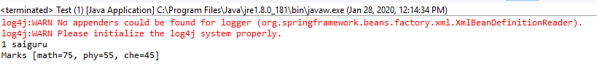

**2.Write a spring MVC web application which will insert rows to a database table. Use Hibernate to persist the data into the database. Use Annotations instead of XML wherever possible. Use service & DAO layers. Table should have 5 columns. Insert 10 rows from a html form. "**

Program:

Employee.java

**public** **class** Employee {

**private** String empName;

**private** **float** empSal;

**private** **int** empId;

**public** String getEmpName() {

**return** empName;

}

**public** **void** setEmpName(String empName) {

**this**.empName = empName;

}

**public** **float** getEmpSal() {

**return** empSal;

}

**public** **void** setEmpSal(**float** empSal) {

**this**.empSal = empSal;

}

**public** **int** getEmpId() {

**return** empId;

}

**public** **void** setEmpId(**int** empId) {

**this**.empId = empId;

}

}

EmployeeVO.java

**import** java.util.Date;

**import** javax.persistence.Entity;

**import** javax.persistence.GeneratedValue;

**import** javax.persistence.GenerationType;

**import** javax.persistence.Id;

**import** javax.persistence.Table;

**import** javax.persistence.Temporal;

**import** javax.persistence.TemporalType;

**import** org.springframework.format.annotation.DateTimeFormat;

@Entity

@Table

**public** **class** EmployeeVO {

**private** String password;

**public** String getPassword() {

**return** password;

}

**public** **void** setPassword(String password) {

**this**.password = password;

}

**public** Date getDoj() {

**return** doj;

}

**public** **void** setDoj(Date doj) {

**this**.doj = doj;

}

@Temporal(TemporalType.***DATE***)

@DateTimeFormat(pattern="yyyy-MM-dd")

**private** Date doj;

**private** String empName;

**private** **float** empSal;

**private** **long** mobile;

**public** **long** getMobile() {

**return** mobile;

}

**public** **void** setMobile(**long** mobile) {

**this**.mobile = mobile;

}

@Id

@GeneratedValue(strategy = GenerationType.***AUTO*** )

**private** **int** empId;

**public** String getEmpName() {

**return** empName;

}

**public** **void** setEmpName(String empName) {

**this**.empName = empName;

}

**public** **float** getEmpSal() {

**return** empSal;

}

**public** **void** setEmpSal(**float** empSal) {

**this**.empSal = empSal;

}

**public** **int** getEmpId() {

**return** empId;

}

**public** **void** setEmpId(**int** empId) {

**this**.empId = empId;

}

}

EmpController.java

**import** java.util.List;

**import** org.hibernate.Query;

**import** org.hibernate.Session;

**import** org.hibernate.SessionFactory;

**import** org.hibernate.Transaction;

**import** org.hibernate.boot.registry.StandardServiceRegistry;

**import** org.hibernate.boot.registry.StandardServiceRegistryBuilder;

**import** org.springframework.beans.factory.annotation.Autowired;

**import** org.springframework.stereotype.Controller;

**import** org.springframework.stereotype.Repository;

**import** org.springframework.transaction.annotation.Transactional;

**import** org.springframework.ui.Model;

**import** org.springframework.web.bind.annotation.ModelAttribute;

**import** org.springframework.web.bind.annotation.RequestMapping;

**import** org.springframework.web.bind.annotation.RequestMethod;

**import** org.springframework.web.bind.annotation.RequestParam;

**import** org.springframework.web.servlet.ModelAndView;

**import** oracle.net.aso.s;

@Controller

@Repository

@Transactional

**public** **class** EmpController {

@Autowired

**private** SessionFactory sessionFactory;

@RequestMapping("/date")

String dateTest(@ModelAttribute EmployeeVO vo) {

System.***out***.println("id is"+vo.getDoj());

System.***out***.println(vo.getEmpId());

**return** "FindEmp";

}

@RequestMapping("/viewAll")

String login(Model m) {

Query q=sessionFactory.openSession().createQuery("from EmployeeVO");//where empId=:Idno and mobile=:mob");

List<EmployeeVO> evol= (List<EmployeeVO>) q.list();

System.***out***.println(evol.size());

m.addAttribute("key", evol);

**return** "DispAll";

}

@RequestMapping("/login")

String login(@RequestParam("empID") **int** id,@RequestParam("mobile") **long** mobile,Model m) {

Query q=sessionFactory.openSession().createQuery("from EmployeeVO where empId=:Idno and mobile=:mob");

q.setParameter("Idno", id);

q.setParameter("mob", mobile);

EmployeeVO evo= (EmployeeVO) q.uniqueResult();

**if**(evo==**null**) {

m.addAttribute("key", "Please enter valid empId or mobile ");

**return** "Login";

}

**else**{

m.addAttribute("key", evo);

**return** "Home";

}

}

@RequestMapping("/find")

String search(@RequestParam("empID") **int** id, Model m) {

EmployeeVO evo= (EmployeeVO) sessionFactory.openSession().get(EmployeeVO.**class**,id);

**if**(evo==**null**) {

m.addAttribute("key", "Please enter valid id");

**return** "FindEmp";

}

**else**{

m.addAttribute("key", evo);

**return** "Disp";

}

}

@Transactional

@RequestMapping("/delete")

String delete(@RequestParam("empID") **int** id, Model m) {

Session session=sessionFactory.openSession();

Transaction transactional=session.beginTransaction();

EmployeeVO evo= (EmployeeVO) session.get(EmployeeVO.**class**,id);

**if**(evo==**null**) {

m.addAttribute("key", "Please enter valid id");

**return** "Delete";

}

**else**{

evo.setEmpId(id);

session.delete(evo);

transactional.commit();

m.addAttribute("deleteKey", id+"Deleted");

**return** "Home";

}

}

@RequestMapping(value="/SignUp",method = RequestMethod.***POST***)

ModelAndView register(@ModelAttribute EmployeeVO emp) {

Session session = sessionFactory.openSession();

Transaction t = session.beginTransaction();

**int** no=(**int**)sessionFactory.openSession().save(emp);

t.commit();

**return** **new** ModelAndView("Login");//

}

}

springhiber-servlet.xml

<?xml version=*"1.0"* encoding=*"UTF-8"*?>

<beans:beans

xmlns=*"http://www.springframework.org/schema/mvc"*

xmlns:xsi=*"http://www.w3.org/2001/XMLSchema-instance"*

xmlns:beans=*"http://www.springframework.org/schema/beans"*

xmlns:context=*"http://www.springframework.org/schema/context"*

xmlns:tx=*"http://www.springframework.org/schema/tx"*

xsi:schemaLocation=*"http://www.springframework.org/schema/mvc http://www.springframework.org/schema/mvc/spring-mvc.xsd*

*http://www.springframework.org/schema/beans http://www.springframework.org/schema/beans/spring-beans.xsd*

*http://www.springframework.org/schema/context http://www.springframework.org/schema/context/spring-context.xsd*

*http://www.springframework.org/schema/tx http://www.springframework.org/schema/tx/spring-tx-4.0.xsd"*>

<annotation-driven />

<!-- <resources mapping="/resources/**" location="/resources/" /> -->

<context:component-scan base-package=*"com.cs"* />

<beans:bean

class=*"org.springframework.web.servlet.view.InternalResourceViewResolver"*>

<beans:property name=*"prefix"* value=*"/"* />

<beans:property name=*"suffix"* value=*".jsp"* />

</beans:bean>

<beans:bean id=*"dataSource"*

class=*"org.apache.commons.dbcp.BasicDataSource"* destroy-method=*"close"*>

<beans:property name=*"driverClassName"*

value=*"oracle.jdbc.driver.OracleDriver"* />

<beans:property name=*"url"*

value=*"jdbc:oracle:thin:@localhost:1521:xe"* />

<beans:property name=*"username"* value=*"system"* />

<beans:property name=*"password"* value=*"system"* />

</beans:bean>

<beans:bean id=*"hibernate4AnnotatedSessionFactory"*

class=*"org.springframework.orm.hibernate4.LocalSessionFactoryBean"*>

<beans:property name=*"dataSource"* ref=*"dataSource"* />

<beans:property name=*"annotatedClasses"*>

<beans:list>

<beans:value>com.cs.EmployeeVO</beans:value>

</beans:list>

</beans:property>

<beans:property name=*"hibernateProperties"*>

<beans:props>

<beans:prop key=*"hibernate.dialect"*>org.hibernate.dialect.Oracle9Dialect

</beans:prop>

<beans:prop key=*"hibernate.hbm2ddl.auto"*>update</beans:prop>

<beans:prop key=*"hibernate.show_sql"*>true</beans:prop>

</beans:props>

</beans:property>

</beans:bean>

<tx:annotation-driven

transaction-manager=*"transactionManager"* />

<beans:bean id=*"transactionManager"*

class=*"org.springframework.orm.hibernate4.HibernateTransactionManager"*>

<beans:property name=*"sessionFactory"*

ref=*"hibernate4AnnotatedSessionFactory"* />

</beans:bean>

</beans:beans>

Springmvc-servlet.xml

<?xml version=*"1.0"* encoding=*"UTF-8"*?>

<beans xmlns=*"http://www.springframework.org/schema/beans"*

xmlns:xsi=*"http://www.w3.org/2001/XMLSchema-instance"*

xmlns:context=*"http://www.springframework.org/schema/context"*

xmlns:mvc=*"http://www.springframework.org/schema/mvc"*

xsi:schemaLocation=*"http://www.springframework.org/schema/beans http://www.springframework.org/schema/beans/spring-beans.xsd*

*http://www.springframework.org/schema/context http://www.springframework.org/schema/context/spring-context-4.3.xsd*

*http://www.springframework.org/schema/mvc http://www.springframework.org/schema/mvc/spring-mvc-4.3.xsd"*>

<context:component-scan base-package=*"com.cs"* />

<bean id=*"viewResolver"*

class=*"org.springframework.web.servlet.view.InternalResourceViewResolver"*>

<property name=*"prefix"* value=*"/"*></property>

<property name=*"suffix"* value=*".jsp"*></property>

</bean>

</beans>

<!-- <?xml version="1.0" encoding="UTF-8"?> <beans xmlns="http://www.springframework.org/schema/beans"

xmlns:xsi="http://www.w3.org/2001/XMLSchema-instance" xmlns:aop="http://www.springframework.org/schema/aop"

xmlns:context="http://www.springframework.org/schema/context" xmlns:jee="http://www.springframework.org/schema/jee"

xmlns:lang="http://www.springframework.org/schema/lang" xmlns:p="http://www.springframework.org/schema/p"

xmlns:tx="http://www.springframework.org/schema/tx" xmlns:util="http://www.springframework.org/schema/util"

xmlns:mvc="http://www.springframework.org/schema/mvc" xsi:schemaLocation="http://www.springframework.org/schema/beans

http://www.springframework.org/schema/beans/spring-beans-3.2.xsd http://www.springframework.org/schema/aop

http://www.springframework.org/schema/aop/spring-aop.xsd http://www.springframework.org/schema/context

http://www.springframework.org/schema/context/spring-context-3.0.xsd http://www.springframework.org/schema/jee

http://www.springframework.org/schema/jee/spring-jee.xsd http://www.springframework.org/schema/lang

http://www.springframework.org/schema/lang/spring-lang.xsd http://www.springframework.org/schema/tx

http://www.springframework.org/schema/tx/spring-tx-3.0.xsd http://www.springframework.org/schema/util

http://www.springframework.org/schema/util/spring-util.xsd http://www.springframework.org/schema/mvc

http://www.springframework.org/schema/mvc/spring-mvc-3.0.xsd"> <context:component-scan

base-package="com.cs" /> <bean class="org.springframework.web.servlet.view.InternalResourceViewResolver">

<property name="prefix" value="/"></property> <property name="suffix" value=".jsp"></property>

</bean> </beans> -->

Web.xml

<?xml version=*"1.0"* encoding=*"UTF-8"*?>

<web-app xmlns:xsi=*"http://www.w3.org/2001/XMLSchema-instance"*

xmlns=*"http://java.sun.com/xml/ns/javaee"*

xsi:schemaLocation=*"http://java.sun.com/xml/ns/javaee http://java.sun.com/xml/ns/javaee/web-app_2_5.xsd"*

id=*"WebApp_ID"* version=*"2.5"*>

<display-name>springwithhibernate</display-name>

<welcome-file-list>

<welcome-file>index.html</welcome-file>

<welcome-file>index.htm</welcome-file>

<welcome-file>index.jsp</welcome-file>

<welcome-file>default.html</welcome-file>

<welcome-file>default.htm</welcome-file>

<welcome-file>default.jsp</welcome-file>

</welcome-file-list>

<servlet>

<servlet-name>springhiber</servlet-name>

<servlet-class>org.springframework.web.servlet.DispatcherServlet</servlet-class>

<load-on-startup>1</load-on-startup>

</servlet>

<servlet-mapping>

<servlet-name>springhiber</servlet-name>

<url-pattern>*.cs</url-pattern>

</servlet-mapping>

<context-param>

<param-name>contextConfigLocation</param-name>

<param-value>WEB-INF/springmvc-servlet.xml</param-value>

</context-param>

</web-app>

DateCheck.jsp

<!DOCTYPE html>

<html>

<head>

<style>

*.submit* {

background: *#25A6E1*;

filter: *progid*: *DXImageTransform.Microsoft.gradient*( *startColorstr*=*'#25A6E1',*

*endColorstr*=*'#188BC0', GradientType*=*0)*;

padding: *3px 5px*;

color: *#fff*;

font-family: *'Helvetica Neue', sans-serif*;

font-size: *12px*;

border-radius: *10px*;

-moz-border-radius: *2px*;

-webkit-border-radius: *4px*;

border: *1px solid #1A87B9*

}

**table** {

font-family: *"Helvetica Neue", Helvetica, sans-serif*;

width: *50%*;

}

**tr** {

background: *SteelBlue*;

color: *white*;

}

**td,** **tr** {

border: *1px solid gray*;

width: *25%*;

text-align: *left*;

padding: *5px 10px*;

}

</style>

<meta charset=*"ISO-8859-1"*>

<title>Insert title here</title>

</head>

<body>

<form action=*"date.cs"*>

<table align=*"center"*>

<tr>

<td>Dob</td>

<td><input type=*"date"* name=*"doj"*></td>

</tr>

<tr>

<td></td>

<td><input type=*"submit"* value=*"Search"*></td>

</tr>

</table>

</form>

</body>

</html>

Delete.jsp

<!DOCTYPE html>

<html>

<head>

<style>

@import *url("mystyles.css")*;

</style>

<meta charset=*"ISO-8859-1"*>

<title>Insert title here</title>

</head>

<body>

<h1 align=*"center"*>

<font color=*"red"*>${key}</font>

</h1>

<form action=*"delete.cs"*>

<table align=*"center"*>

<tr>

<td>empId</td>

<td><input type=*"text"* name=*"empID"*></td>

</tr>

<tr>

<td></td>

<td><input type=*"submit"* value=*"Delete"*></td>

</tr>

</table>

</form>

</body>

</html>

Disp.jsp

<%@ page language=*"java"* contentType=*"text/html; charset=ISO-8859-1"*

pageEncoding=*"ISO-8859-1"*%>

<!DOCTYPE html>

<html>

<head>

<style>

@import *url("mystyles.css")*;

</style>

<meta charset=*"ISO-8859-1"*>

<title>Insert title here</title>

</head>

<body>

<table align=*"center"* border=*"10"* cellspacing=*"10"*>

<tr>

<td>${key.empId}</td>

<td>${key.empName}</td>

<td>${key.empSal}</td>

<td>${key.mobile}</td>

<td>${key.doj}</td>

</tr>

</table>

</body>

</html>

DispAll.jsp

<%@ page language=*"java"* contentType=*"text/html; charset=ISO-8859-1"*

pageEncoding=*"ISO-8859-1"*%>

<%@ taglib uri=*"http://java.sun.com/jsp/jstl/core"* prefix=*"sd"*%>

<!DOCTYPE html PUBLIC "-//W3C//DTD HTML 4.01 Transitional//EN" "http://www.w3.org/TR/html4/loose.dtd">

<html>

<head>

<style type=*"text/css"*>

@import *url("mystyles.css")*;

</style>

<meta http-equiv=*"Content-Type"* content=*"text/html; charset=ISO-8859-1"*>

<title>Insert title here</title>

</head>

<body bgcolor=*"cyan"*>

<h1 align=*"center"*>Trainers Info</h1>

<table>

<tr bgcolor=*"tomato"*>

<td bgcolor=*"tomato"*>EmpID</td>

<td bgcolor=*"tomato"*>EmpName</td>

<td bgcolor=*"tomato"*>Salary</td>

<td bgcolor=*"tomato"*>DOJ</td>

<td bgcolor=*"tomato"*>MobileNo</td>

</tr>

<sd:forEach var=*"emp"* items=*"*${key}*"*>

<tr>

<td>${emp.empId}</td>

<td>${emp.empName}</td>

<td>${emp.empSal}</td>

<td>${emp.doj}</td>

<td>${emp.mobile}</td>

</tr>

</sd:forEach>

</table>

<div id=*"trainer_data"*></div>

</body>

</html>

FindEmp.jsp

<!DOCTYPE html>

<html>

<head>

<style>

@import *url("mystyles.css")*;

/* .submit {

background: #25A6E1;

filter: progid: DXImageTransform.Microsoft.gradient( startColorstr='#25A6E1',

endColorstr='#188BC0', GradientType=0);

padding: 3px 5px;

color: #fff;

font-family: 'Helvetica Neue', sans-serif;

font-size: 12px;

border-radius: 10px;

-moz-border-radius: 2px;

-webkit-border-radius: 4px;

border: 1px solid #1A87B9

}

table {

font-family: "Helvetica Neue", Helvetica, sans-serif;

width: 50%;

}

tr {

background: SteelBlue;

color: white;

}

td, tr {

border: 1px solid gray;

width: 25%;

text-align: left;

padding: 5px 10px;

} */

</style>

<meta charset=*"ISO-8859-1"*>

<title>Insert title here</title>

</head>

<body>

<h1 align=*"center"*><font color=*"red"*>${key}</font></h1>

<form action=*"find.cs"*>

<table align=*"center"*>

<tr>

<td>UserName</td>

<td><input type=*"text"* name=*"empID"*></td>

</tr>

<!-- <tr>

<td>Dob</td>

<td><input type="date" name="doj"></td>

</tr> -->

<tr>

<td></td>

<td><input type=*"submit"* value=*"Search"*></td>

</tr>

</table>

</form>

</body>

</html>

Home.jsp

<%@ page language=*"java"* contentType=*"text/html; charset=ISO-8859-1"*

pageEncoding=*"ISO-8859-1"*%>

<!DOCTYPE html>

<html>

<head>

<style type=*"text/css"*>

@import *url("mystyles.css")*;

</style>

<meta charset=*"ISO-8859-1"*>

<title>Insert title here</title>

</head>

<body>

<table>

<tr>

<td><a href=*"viewAll.cs"*>Display All</a></td>

</tr>

<tr>

<td><a href=*"FindEmp.jsp"*>View My Data </a></td>

</tr>

<tr>

<td><a href=*"Delete.jsp"*>Delete Employee</a> <font color=*"red"*>${deleteKey}</font></td>

</tr>

</table>

</body>

</html>

Login.jsp

<!DOCTYPE html>

<html>

<head>

<script

src=*"https://ajax.googleapis.com/ajax/libs/angularjs/1.6.9/angular.min.js"*></script>

<style>

@import *url("mystyles.css")*;

</style>

<meta charset=*"ISO-8859-1"*>

<title>Insert title here</title>

</head>

<body>

<script>

**var** app = angular.module('myApp', []);

app.controller('validateCtrl', **function**($scope) {

$scope.empID = '001';

$scope.mobile = '9876543210';

});

</script>

<h1 align=*"center"*>

<font color=*"red"*>${key}</font>

</h1>

<form action=*"login.cs"* ng-app=*"myApp"* ng-controller=*"validateCtrl"*

name=*"myForm"* novalidate>

<table align=*"center"*>

<tr>

<td>empId</td>

<td><input type=*"text"* ng-model=*"empID"* name=*"empID"* required>

<span style="color: *black*"

ng-show=*"myForm.empID.$dirty && myForm.empID.$invalid"*> <span

ng-show=*"myForm.empID.$error.required"*>EmpID is required.</span>

</span></td>

</tr>

<tr>

<td>MobileNo</td>

<td><input type=*"text"* name=*"mobile"* ng-model=*"mobile"* required>

<span style="color: *black*"

ng-show=*"myForm.mobile.$dirty && myForm.mobile.$invalid"*> <span

ng-show=*"myForm.mobile.$error.required"*>MObile no is

required.</span>

</span></td>

</tr>

<tr>

<td></td>

<td><input type=*"submit"* style="bg-color: *green*" value=*"click"*

ng-disabled=*"myForm.empID.$dirty && myForm.empID.$invalid ||*

*myForm.mobile.$dirty && myForm.mobile.$invalid"*></td>

</tr>

</table>

</form>

</body>

</html>

Mystyle.css

@charset *"ISO-8859-1"*;

*.submit* {

background: *#800080*;

filter: *progid*: *DXImageTransform.Microsoft.gradient*( *startColorstr*=*'#25A6E1',*

*endColorstr*=*'#188BC0',* *GradientType*=*0)*;

padding: *3px* *5px*;

color: *#c0c0c0*;

font-family: *'Helvetica Neue',* *sans-serif*;

font-size: *20px*;

border-radius: *10px*;

-moz-border-radius: *2px*;

-webkit-border-radius: *4px*;

border: *1px* *solid* *#1A87B9*

}

**table** {

margin-left: *auto*;

margin-right: *auto*;

font-family: *"Helvetica Neue",* *Helvetica,* *sans-serif*;

width: *50%*;

}

**tr** {

background: *Purple*;

color: *white*;

}

**td,** **tr** {

border: *10px* *solid* *#808000*;

width: *25%*;

text-align: *center*;

padding: *10px* *10px*;

color: *white*;

}

**a**{

color: *white*;

text-decoration: *overline*;

}

SignUp.html

<!DOCTYPE html>

<html>

<head>

<script

src=*"https://ajax.googleapis.com/ajax/libs/angularjs/1.6.9/angular.min.js"*></script>

<style>

@import *url("mystyles.css")*;

**input***.ng-invalid* {

background-color: *pink*;

}

**input***.ng-valid* {

background-color: *yellow*;

}

</style>

<meta charset=*"ISO-8859-1"*>

<title>SignupForm</title>

</head>

<body ng-app=*""*>

<form action=*"SignUp.cs"* method=*"post"*>

<table align=*"center"*>

<tr>

<td>Mobile</td>

<td><input type=*"text"* ng-model=*"mobile"* required name=*"mobile"*></td>

</tr>

<tr>

<td>PassWord</td>

<td><input type=*"text"* name=*"passWord"* ng-model=*"passWord"*

required></td>

</tr>

<tr>

<td>EmpName</td>

<td><input type=*"text"* name=*"empName"* ng-model=*"empName"*

required></td>

</tr>

<tr>

<td>DoJ</td>

<td><input type=*"date"* name=*"doj"* ng-model=*"doj"* required></td>

</tr>

<tr>

<td>Salary</td>

<td><input type=*"text"* name=*"empSal"* ng-model=*"empSal"* required></td>

</tr>

<tr>

<td></td>

<td><input type=*"submit"* class=*"submit"* value=*"Register"*></td>

</tr>

</table>

</form>

</body>

</html>

**Output:- validations for html**

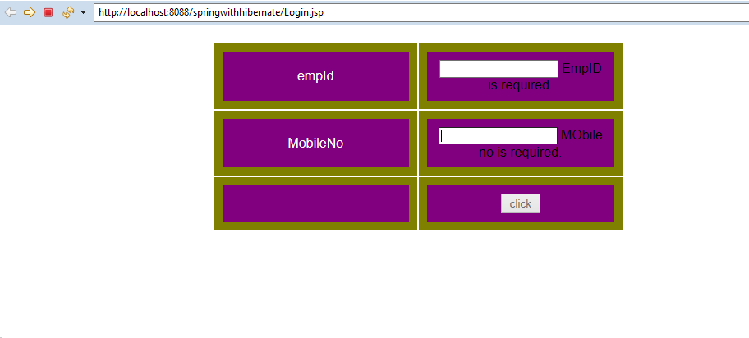

Home Page

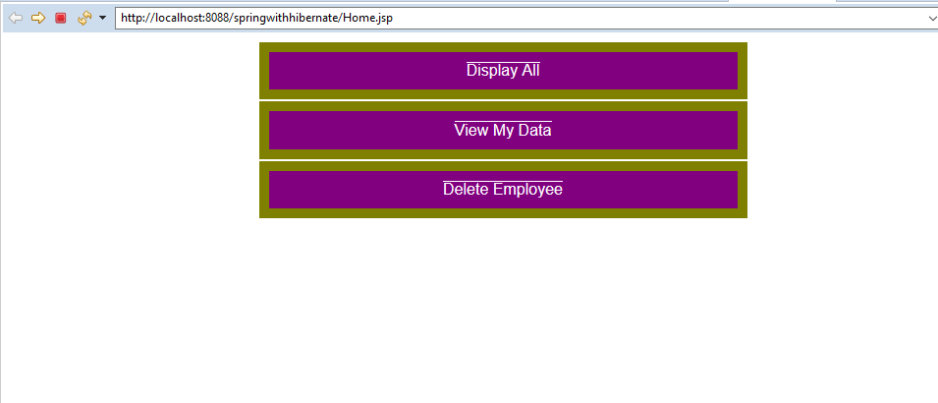

Delete page

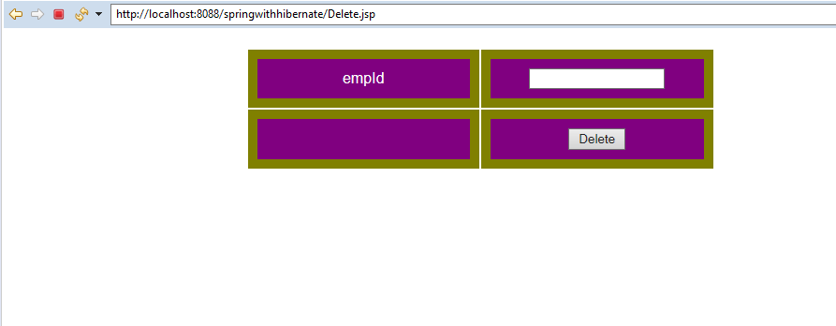

3.Create an angular application which calculate simple interest. Principal amt, rate and time should enter by user in text fields. These textfields(model) will be used to calculate interest. Use ng-model directive and data binding to perform the above given task

<!DOCTYPE html>

<html>

<script src= "http://ajax.googleapis.com/ajax/libs/angularjs/1.3.14/angular.min.js"></script>

<head>

<style>

table {

width: 640px;

border-collapse: collapse;

border-spacing: 0;

background-color:black; color:white;

}div{border-style: none; border-width:3; border-color: #FFFFFF;}

td, th { border: 2px solid #CCC;padding: 10px;}</style>

</head>

<body><br/><br/><br/>

<center><h4>SIMPLE INTEREST CALCULATOR</h4></center>

<div ng-app="TestFirstApp" ng-controller="TestCtrl">

<table align="center">

// Here the Values are Given by the user

<tr><td>PRINCIPAL AMOUNT: </td><td><input type="number" ng-model="amt" ></td></tr>

<tr><td>RATE : </td><td><input type="number" ng-model="rate"></td></tr>

<tr><td>TIME : </td><td><input type="number" ng-model="time"></td></tr>

<tr>

<td></td><td><font size=5>Simple Interest Amount: {{ + interestamt()}}</font></td>

<tr>

</table>

</div>

<script>

var app = angular.module('TestFirstApp', []);

app.controller('TestCtrl', function($scope) {

$scope.amt = "";

$scope.time = "";

$scope.rate= "";

$scope.interestamt= function() {

return ($scope.amt*$scope.rate*$scope.time)/100;

};

});

</script>

</body>

</html>

**Output:-1 First the HTML FORM is Blank Because the values are given by the user**

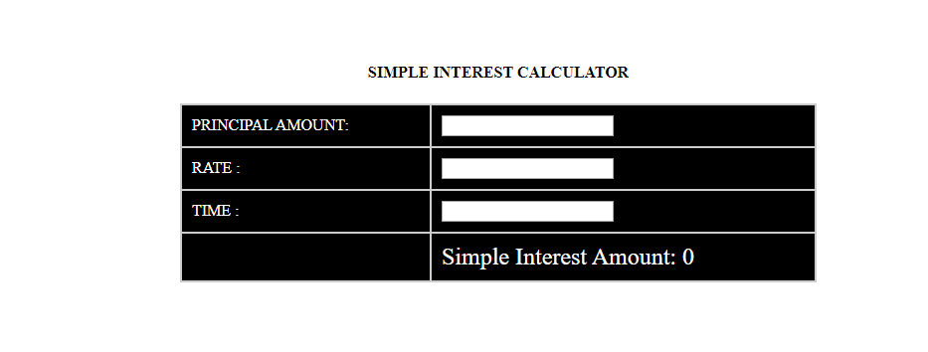

**OUTPUT2:The Values are given by the user**

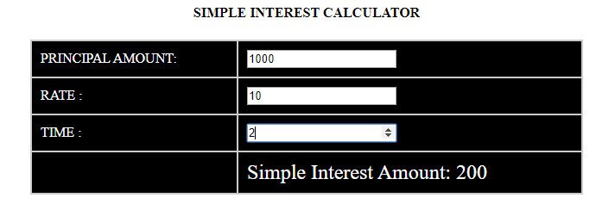

emp.jsp:

<%@ page language=*"java"* contentType=*"text/html; charset=ISO-8859-1"*

pageEncoding=*"ISO-8859-1"*%>

<!DOCTYPE html PUBLIC "-//W3C//DTD HTML 4.01 Transitional//EN" "http://www.w3.org/TR/html4/loose.dtd">

<html>

<head>

<meta http-equiv=*"Content-Type"* content=*"text/html; charset=ISO-8859-1"*>

<title>Employee Search</title>

</head>

<body>

<table>

<tr>

<td>Emp ID</td>

<td ><input type=*'text'* id=*'empID'* /></td>

</tr>

<!-- <input type='button' value='get' onclick='getEmployee();' /> -->

<tr>

<td>Name</td>

<td><input type=*'text'* id=*'empName'* disabled /></td>

</tr>

<tr>

<td>City</td>

<td><input type=*'text'* id=*'city'* disabled /></td>

</tr>

<tr><td colspan=*"2"*><input type=*'button'* value=*'getData'* onclick='getEmployee();' /></td></tr>

</table>

<script>

**var** xhttp;

**function** getEmployee() {

**if** (window.XMLHttpRequest) {

xhttp = **new** XMLHttpRequest();

} **else** **if** (window.ActiveXObject)//for IE

{

xhttp = **new** ActiveXObject("Microsoft.XMLHTTP");

}

**var** empID = document.getElementById("empID").value;

xhttp.onreadystatechange = getResponse;

xhttp.open("GET", "getemployee/" + empID, **true**);

xhttp.send(**null**);

}

**function** getResponse() {

**if** (xhttp.readyState == 4) //if request is complete

{

**if** (xhttp.status == 200)

{

**var** emp = JSON.parse(xhttp.responseText);

document.getElementById("empName").value = emp.empName;

document.getElementById("city").value = emp.city;

}

}

}

</script>

</body>

</html>

EmployeeVO.java:

**package** com.hc.model;

**import** javax.persistence.Entity;

**import** javax.persistence.GeneratedValue;

**import** javax.persistence.GenerationType;

**import** javax.persistence.Id;

**import** javax.persistence.Table;

**import** javax.persistence.Temporal;

**import** javax.persistence.TemporalType;

@Entity

@Table

**public** **class** EmployeeVO {

**private** String empName;

**private** String city;

@Id

@GeneratedValue(strategy = GenerationType.***AUTO*** )

**public** String getEmpName() {

**return** empName;

}

**public** **void** setEmpName(String empName) {

**this**.empName = empName;

}

**public** String getCity() {

**return** city;

}

**public** **void** setCity(String city) {

**this**.city = city;

}

}

EmpRestController.java:

package com.hc.model;

import org.hibernate.SessionFactory;

import org.springframework.beans.factory.annotation.Autowired;

import org.springframework.stereotype.Controller;

import org.springframework.ui.Model;

import org.springframework.web.bind.annotation.PathVariable;

import org.springframework.web.bind.annotation.RequestMapping;

import org.springframework.web.bind.annotation.RequestMethod;

import org.springframework.web.bind.annotation.RequestParam;

import org.springframework.web.bind.annotation.RestController;

@RestController

public class EmpRestController {

@Autowired

SessionFactory sessionFactory;

@RequestMapping(value = "/getemployee/{empID}", method = RequestMethod.GET)

EmployeeVO search(@PathVariable("empID") int id, Model m) {

EmployeeVO evo1=new EmployeeVO();

evo1.setEmpName("NodataFound");

EmployeeVO evo= (EmployeeVO) sessionFactory.openSession().get(EmployeeVO.class,id);

if(evo!=null) {

return evo;

}

else {

return evo1;

}

}

}

Web.xml:

<?xml version=*"1.0"* encoding=*"UTF-8"*?>

<web-app xmlns:xsi=*"http://www.w3.org/2001/XMLSchema-instance"*

xmlns=*"http://xmlns.jcp.org/xml/ns/javaee"*

xsi:schemaLocation=*"http://xmlns.jcp.org/xml/ns/javaee*

*http://xmlns.jcp.org/xml/ns/javaee/web-app_3_1.xsd"*

version=*"3.1"*>

<display-name> SpringWebService </display-name>

<servlet>

<servlet-name>dispatcher</servlet-name>

<servlet-class>

org.springframework.web.servlet.DispatcherServlet

</servlet-class>

<load-on-startup>1</load-on-startup>

</servlet>

<servlet-mapping>

<servlet-name>dispatcher</servlet-name>

<url-pattern>/</url-pattern>

</servlet-mapping>

</web-app>

Dispatcher-servlet.xml:

<?xml version=*"1.0"* encoding=*"UTF-8"*?>

<beans xmlns:mvc=*"http://www.springframework.org/schema/mvc"*

xmlns:xsi=*"http://www.w3.org/2001/XMLSchema-instance"*

xmlns=*"http://www.springframework.org/schema/beans"*

xmlns:context=*"http://www.springframework.org/schema/context"*

xmlns:tx=*"http://www.springframework.org/schema/tx"*

xsi:schemaLocation=*"http://www.springframework.org/schema/mvc http://www.springframework.org/schema/mvc/spring-mvc.xsd*

*http://www.springframework.org/schema/beans http://www.springframework.org/schema/beans/spring-beans.xsd*

*http://www.springframework.org/schema/tx http://www.springframework.org/schema/tx/spring-tx.xsd*

*http://www.springframework.org/schema/context http://www.springframework.org/schema/context/spring-context.xsd"*>

<context:component-scan base-package=*"com.hcl"* />

<mvc:annotation-driven/>

</beans>

Output:-



Displaying

